Here is the modified Project Scope.

Assumption: All Level 3 and Level 4 students' required details are currently available in the database.

- Students shall Sign Up by entering :
1. Full Name
2. Index Number
3. University Email, and then click Sign Up.

When students enter their index number and their university email, an auto verification will be done when clicking Sign Up.
It should display in a pop-up window.

Then, a One-Time Password will be sent to the entered University Email address. (After a successful auto verification, the student should be redirected to a page that allows them to type their six-digit OTP code.) Then that student can enter that specific OTP on a dedicated page.
After correctly entering the OTP Code on that page, students are instantly redirected to an Initial Password Reset page. So, here student can enter their New Password and confirm their New Password.
After successfully confirming the new password, the student made, Student will be redirected to the Student Dashboard.

From now on Student have full access to the system to do the following.
1. Full CRUD access to customize and edit their own profile details.
2. Add their Skills that they prefer and also the skill level. (beginner, intermediate, advanced).
3. Add their project and give them full CRUD access for them.
4. Customize their CV and download the updated CV.
5. See their academic results and GPA. (Only Computer Science GPA)
I will explain the updated pages and their page structure to students from now on.
1. Students Sign Up page.
Divided into two sides. One side for System Welcome Greeting. And the other side should include the Sign-Up form. The sign-up form should include three fields.
Form should start from the “Sign Up” text.
- Full Name – Student's full Name.
- Index Number – Students' index number.
- University Email – Students' university email address.
And a Sign-Up button.
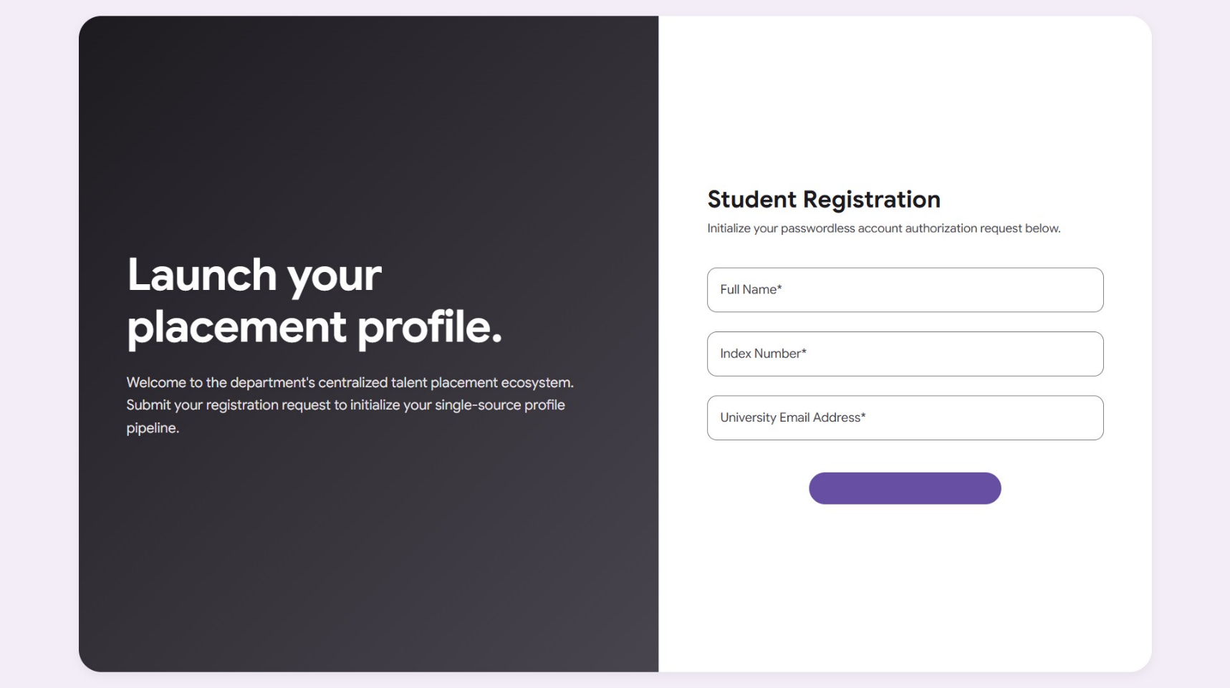
When student clicks this sign-up button, there should be a pop-up that needs to open. This pop up should include three states.
1. Text : “Your details are verifying …”.
A Loading spinner until verifying.
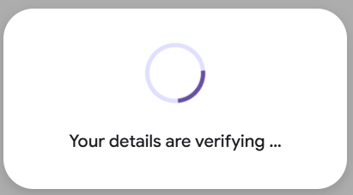
2. Text : “Your details are verified ..”.
A right mark right after loading spinner which should match the current theme.
No Close buttons here, because once students' details are verified, that specific student is redirected to the dedicated OTP entering page.
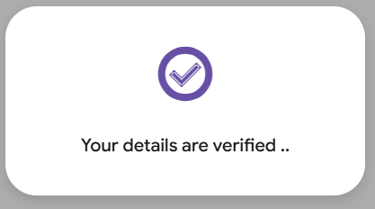
3. Text: “There is an issue with your entered details. Please consider them again and try again.”
A wrong mark right after loading the spinner, which should match the current theme.
Close button.
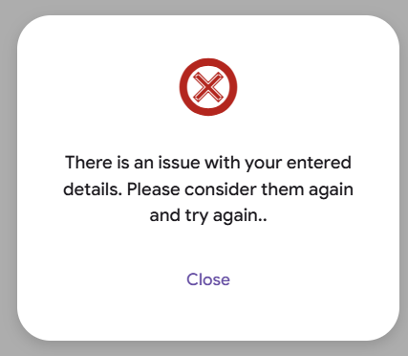
If the entered details have issues in the verification process (State three that mentioned above), then students need to reconsider their entered details in the sign-up form.
Remember: Only the index number and the University Email address are considered for the verification process. Name is for displaying only. And also, students can edit their name on the Profile page. But they can never edit their University Email and the Index number inside the System. Because they are unique values, and each combination of them represents a single student.
Then, right after the successful verification (State two that was mentioned above), the student is redirected to the OTP Entering Page.
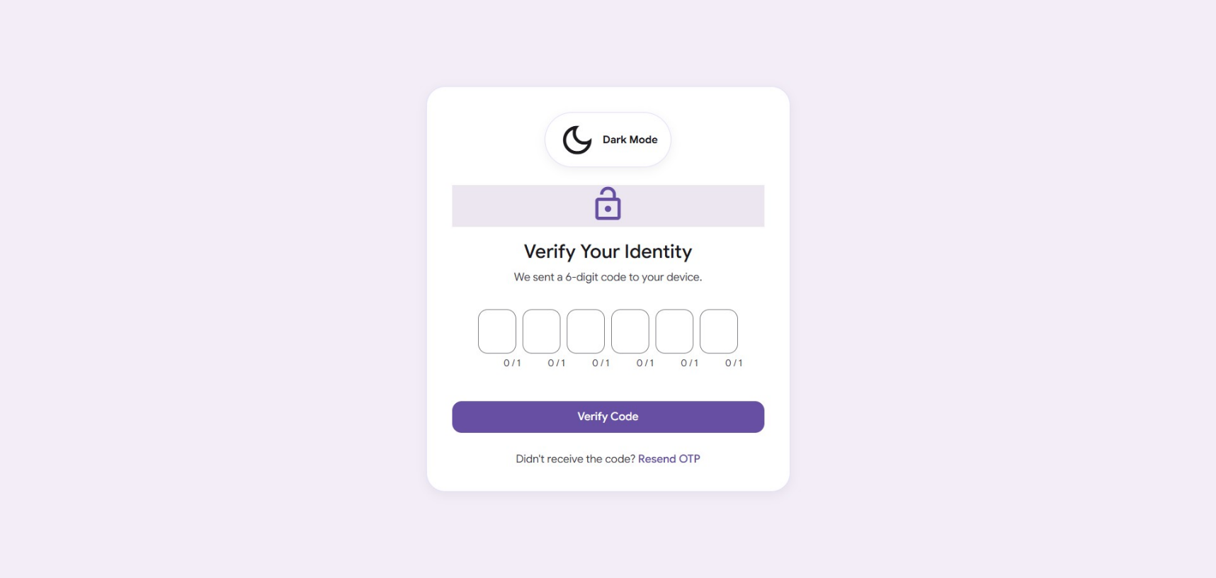

And right after students correctly enter their OTP, they should be redirected to the Password creation page.
This page should start with “Create your new password.”
And the following two fields.
1. New Password.
2. Confirm New Password.
And a Create Password button.
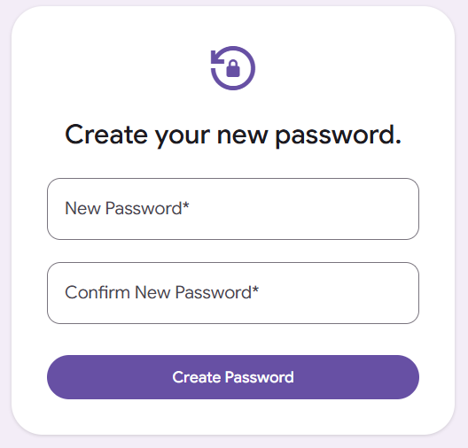

And right after that, the student was redirected to the Student Login page.

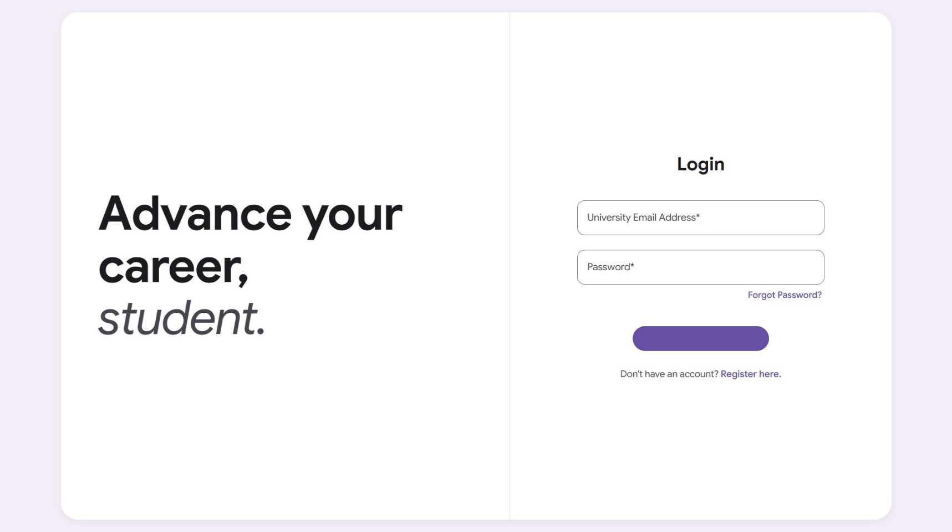

And if students forget the password, they can reset it by clicking the " Forget Password” link. It should redirect to the Forget Password page.
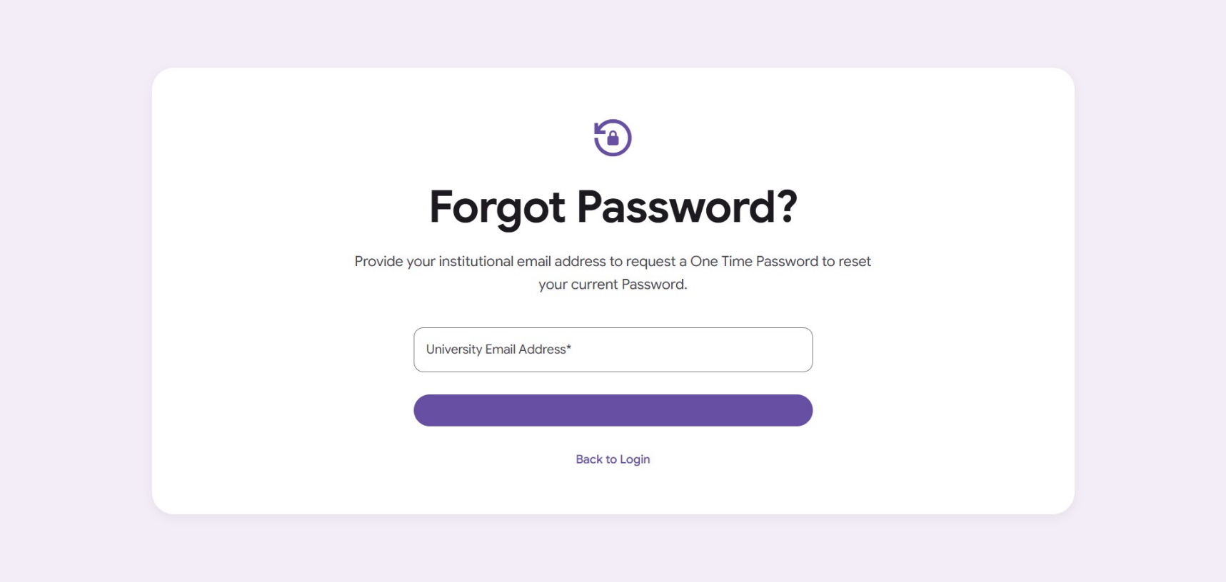

This page starts with a title: Forget Password?.
And a text: Provide your institutional email address to request a One-Time Password to reset your current Password.
And then a text field to enter the student's email address, and then a button labeled “Send OTP”
And right below that button, there should be a link to the login page.
So, after the authentication pages we discussed up to now. Let’s move to the Student Dashboard page.
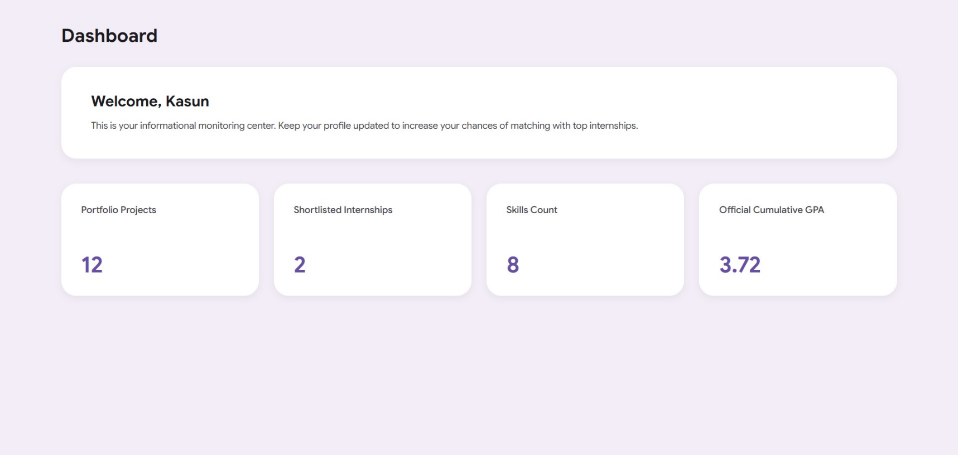

Here is how the page is structured.
• Page Title: Dashboard
• Welcome Panel: Welcome banner card with the student's name and dashboard instructions.
• Metrics Grid: A 4-column layout holding the summary statistics cards.
• Metric Card 1: Portfolio Projects count.
• Metric Card 2: Shortlisted Internships count.
• Metric Card 3: Skills Count.
• Metric Card 4: Official Cumulative GPA value.

And let’s move to the Students’ Profile page.
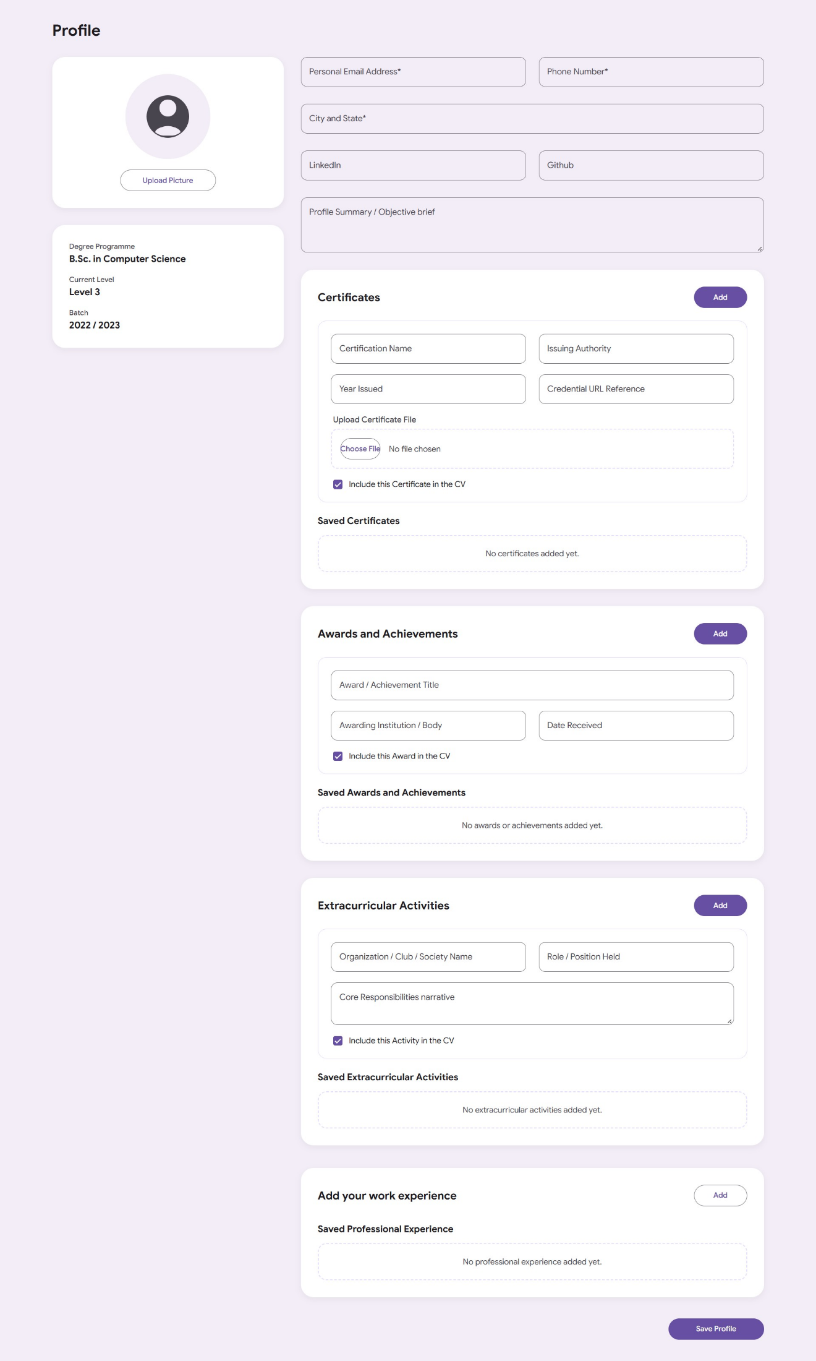

And the professional Experience modal :
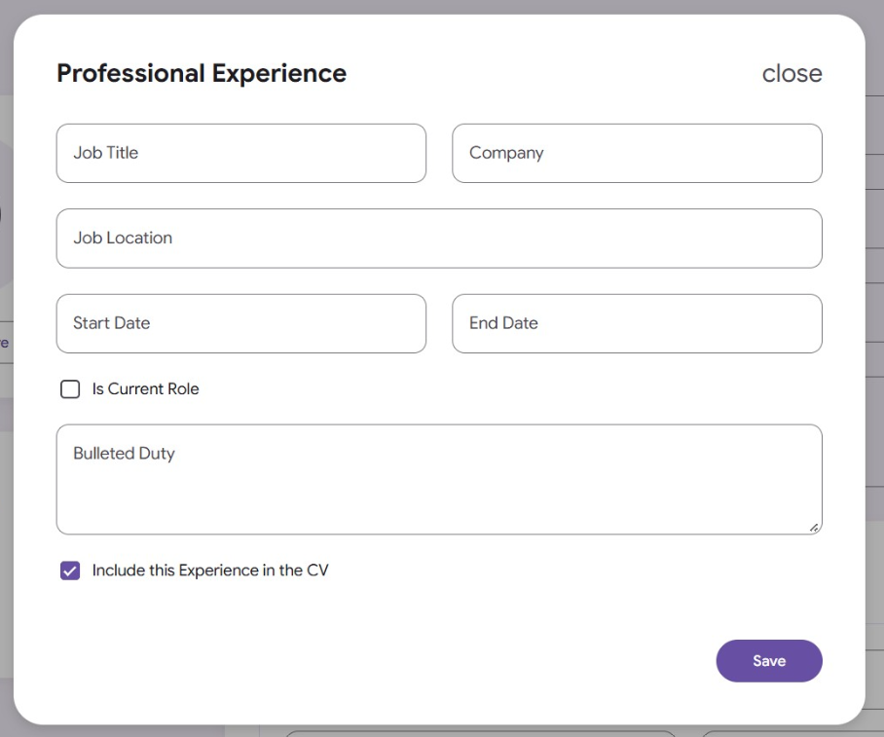
• Page Title: Profile
• Layout Grid: A two-column master interface layout partitioning secondary details from interactive form entries.
- Sidebar Pane (Left Column): Handles academic background tracking cards and the student avatar image upload module.
- From Pane (Right Column): Organizes user text field entries alongside repeating structural section lists.
• Certificates Card Section: Houses child editor forms to capture and append credential milestones dynamically.
• Awards and Achievements Card Section: Captures academic or faculty exhibition recognitions with toggle inclusions.
• Extracurricular Activities Card Section: Manages societal, voluntary, or organizational group role logs.
• Work Experience Card Section: An overview panel triggering dedicated overlay modal windows to record operational workflow histories.
• Professional Experience Modal: A clean focused context window managing job title parameters, timeline durations, and bulleted duties.
• Delete Confirmation Modal: A prompt wrapper tracking clicks perimeters to safely run destructive array modifications.

Main functionalities available to students on this page :
• Profile Picture Management: Upload or update a personal profile picture.
• Academic Information View: View read-only academic details provided by the university, including the Degree Programmed, Current Level, and Batch.
• Contact & Location Updates: Edit and update essential contact details, including a Personal Email Address, Phone Number, and City/State.
• Professional Links: Add or update links to external professional profiles like LinkedIn and GitHub.
• Profile Summary: Write a brief professional objective or summary.
• Dynamic Certificate Tracking:
- Add multiple certifications with details like Name, Issuing Authority, Year, and URL.
- Upload physical certificate files (PDF, PNG, JPG, JPEG).
- Toggle whether each certificate should be included in the generated CV.
- Edit or remove previously saved certificates.
• Awards & Achievements Management: Add, edit, remove, and toggle CV inclusion for academic honors, contest wins, or achievements.
• Extracurricular Activities Logs: Log involvement in clubs, roles held, and descriptions of core responsibilities with CV inclusion controls.
• Professional Work Experience Tracking:
- Launch a pop-up modal to add detailed work experience.
- Input specific parameters like Job Title, Company, Location, Timelines, and a bullet list of duties.
- Mark a position as a "Current Role" to dynamically lock the end date.
- Edit or permanently remove recorded work histories with a safety confirmation check.
• Global Save Profile Action: Submit the entire form to commit all changes and update the underlying database payloads.
Let’s move to the Students Skills Page.
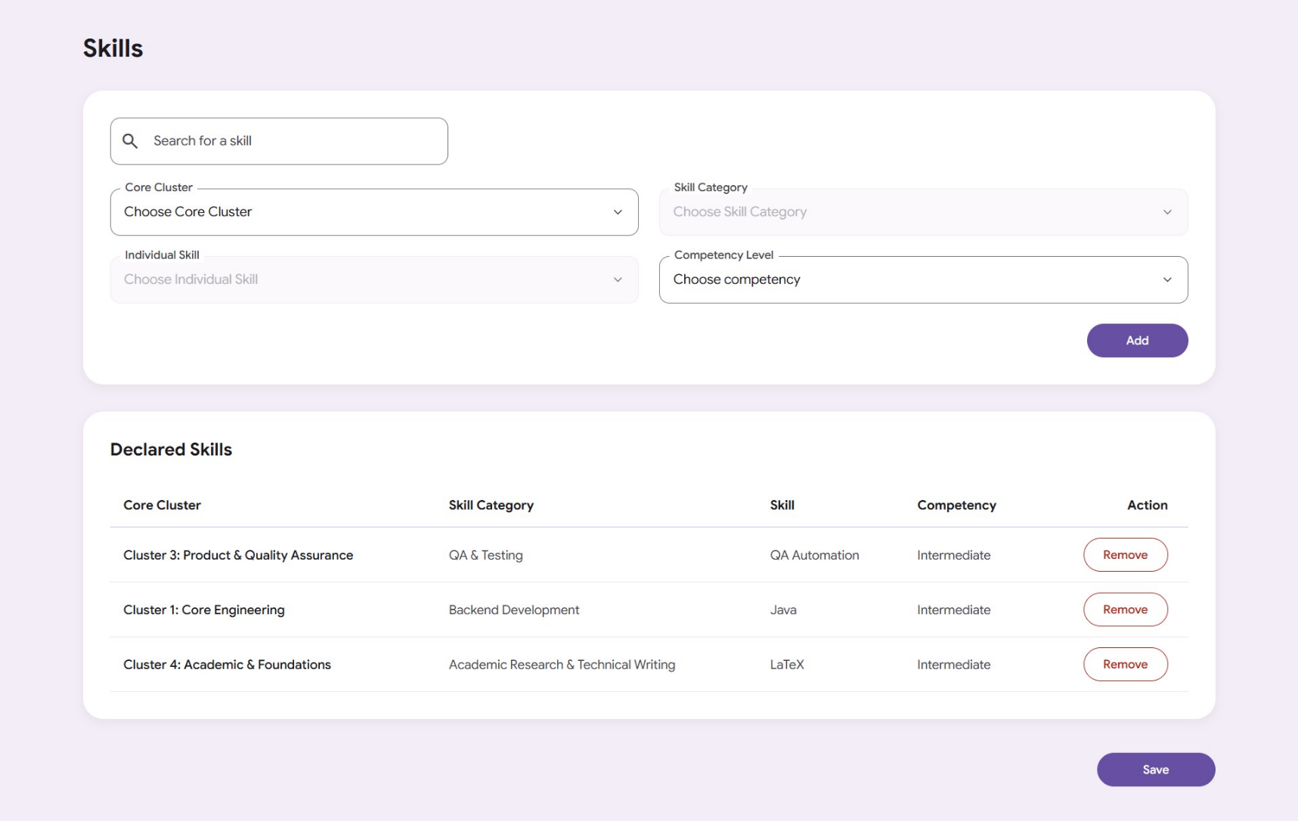

Simple Page Structure Description
- Page Title: Skills
- Inventory Panel: Card container holding the interactive search box and the cascading dropdown fields to select skill classifications.
- Search Field: An outlined material search text box with a magnifying glass icon to filter through your logged entries.
- Taxonomy Selection Fields: A 2x2 structural grid holding native dropdown selectors for the Core Cluster, Skill Category, Individual Skill, and Competency Level.
- Add Action Button: A filled material action button to dynamically insert the selected taxonomy criteria into the table.
- Declared Skills Panel: Card container displaying the structured overview of all declared student skills.
- Skills Inventory Table: A tabular representation mapping out your custom clusters, categories, skills, and mastery statuses.
- Dynamic Remove Action Button: An inline outlined material button located on each active row to instantly evict items from the list.
- Global Inventory Save Button: A primary filled button at the bottom of the page structure to commit all declared updates.

Main functionalities available to students on this page.

- Search/Filter Declared Skills: Use an interactive search box with real-time text filtering to find specific entries from the declared skills list instantly.
- Layered Skill Selection: Select a high-level classification from the "Core Cluster" dropdown menu.
- Cascading Category Selection: Choose a mid-level classification from the "Skill Category" dropdown, which dynamically unlocks and adjusts its options based on the selected cluster.
- Individual Skill Selection: Drill down to pick a specific technical or soft capability from the "Individual Skill" dropdown, which populates contextually based on the chosen category.
- Competency Level Assignment: Assign a self-assessed proficiency grade (Beginner, Intermediate, or Advanced) to the chosen skill.
- Insert New Competencies: Use the "Add" action button to append the newly configured skill taxonomy row to the inventory checklist table.
- Duplication Prevention: Rely on an integrated system guard that alerts and prevents adding an individual skill if it has already been declared.
- Dynamic Table Review: Scan through a structured overview table mapping out all currently declared clusters, categories, skills, and mastery statuses.
- Evict Skills Inventory Rows: Click the inline "Remove" button on any logged row to instantly delete that specific skill entry from the active profile listing.
- Commit Updates Globally: Click the primary "Save" button at the bottom of the page to commit all modifications to the final profile layout.
And let’s move to the Students Project Page.
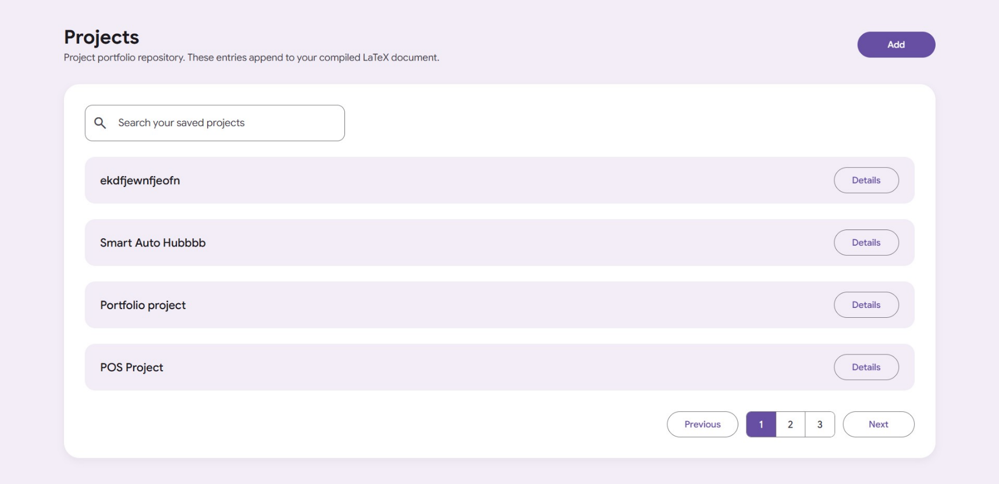

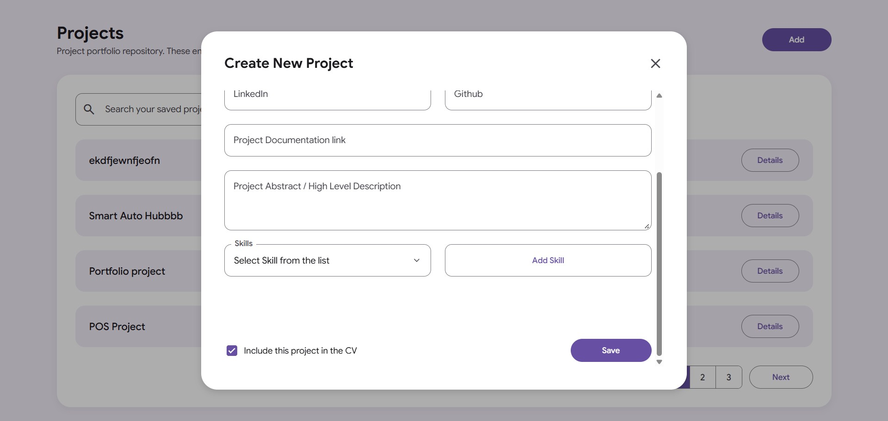

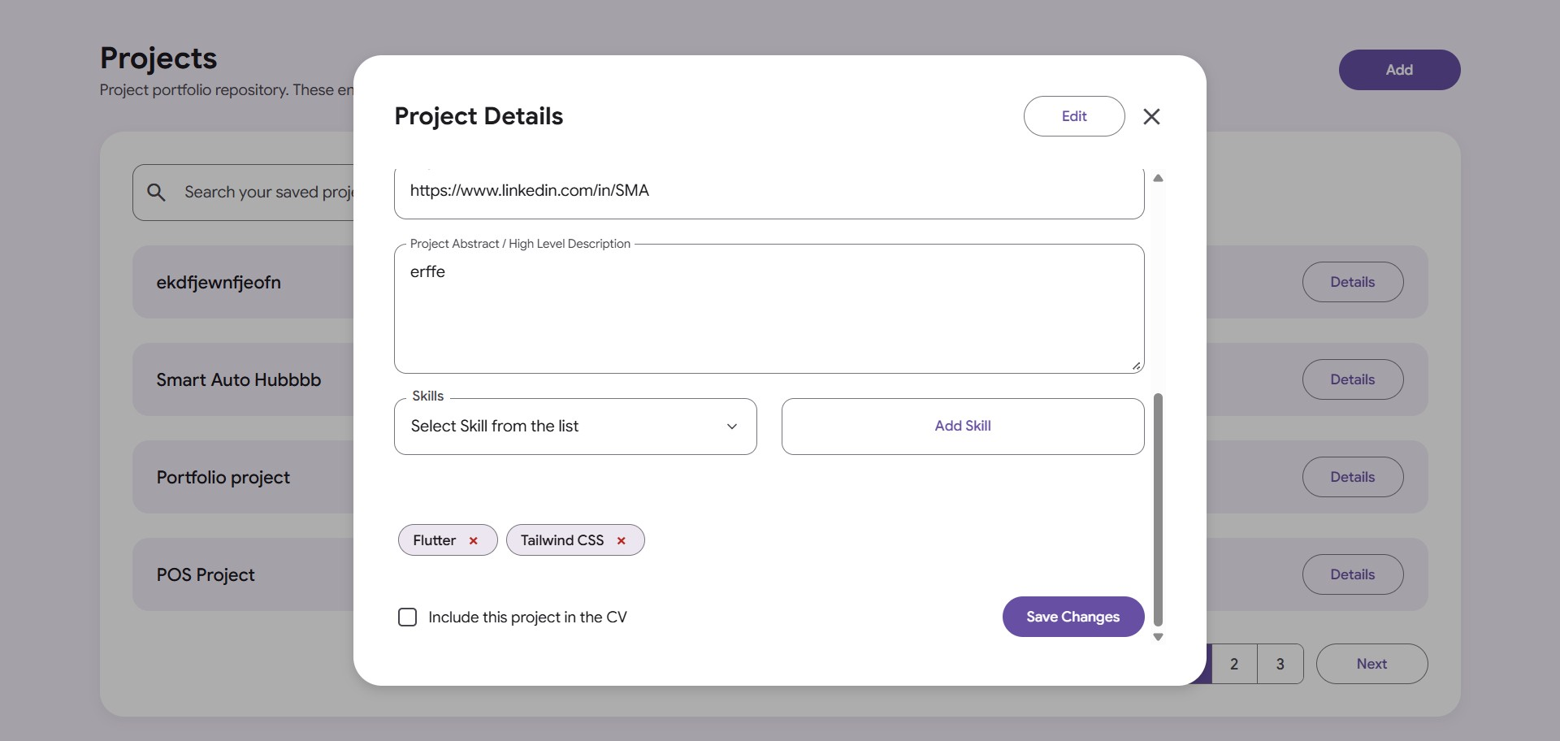

Simple Page Structure Description
- Page Title: Projects
- Main Repository Card: Central container wrapping the search box, project list tracking area, and navigation buttons.
- Search Bar Wrapper: Outlined text input block holding a magnifying glass icon to filter saved projects.
- Dynamic Projects Track: Vertical list that automatically loads saved project rows showing titles and "Details" buttons.
- Pagination Container: Alignment row holding "Previous" and "Next" buttons alongside numerical page page-index squares.
- Create New Project Modal: Pop-up window overlay providing text field blocks to input title, type, timelines, links, abstracts, and select related skill tags.
- Project Details View Modal: Pop-up window card providing a toggleable interface to review, edit, or save changes to a selected project entry.

Main functionalities available to students on this page:
- Launch Project Creation: Click the "Add" button to launch a pop-up window overlay for registering a new project.
- Search Saved Portfolios: Type keywords into the search bar to locate specific entries within their saved projects portfolio.
- View Project Summaries: Review a dynamically rendered list tracking all currently logged projects by title.
- Navigate Pagination Layouts: Move across multiple portfolio lists using "Previous," "Next," and numerical index page buttons.
- Review Detailed Profiles: Click the inline "Details" button on any row to open an overlay displaying a comprehensive record of that project.
- Toggle Timeline Panel: Click the "Timeline" pill badge inside either modal to expand or collapse hidden project scheduling inputs.
- Specify Developmental Status: Check an "Under Development" box to declare a project as ongoing, which dynamically locks and clears the end date picker.
- Log Asset Repositories: Supply and save custom web links tracking related LinkedIn posts, GitHub repositories, and cloud documentation attachments.
- Compose Project Abstracts: Write high-level architectural overview narratives into a dedicated description box.
- Append Taxonomy Skill Tags: Select a technical capability from a dropdown menu and click "Add Skill" to attach it to the project profile.
- Document Skill Usage Notes: Input custom descriptive notes detailing exactly how a selected language or framework was utilized within that project environment.
- Evict Added Skill Components: Click the close cross mark directly on any skill capsule chip to remove it from the active project list.
- Control Resume Layouts: Toggle a CV inclusion checkbox to determine if the selected project profile should append to their generated LaTeX document.
- Initiate Portfolio Editing: Click the "Edit" button inside the details modal window to unlock pre-filled data fields from their default frozen, read-only state.
- Persist Modifications: Click submission action buttons to instantly commit new entries or save structural modifications back to the main track list.

And let’s move to the LaTeX CV builder page.

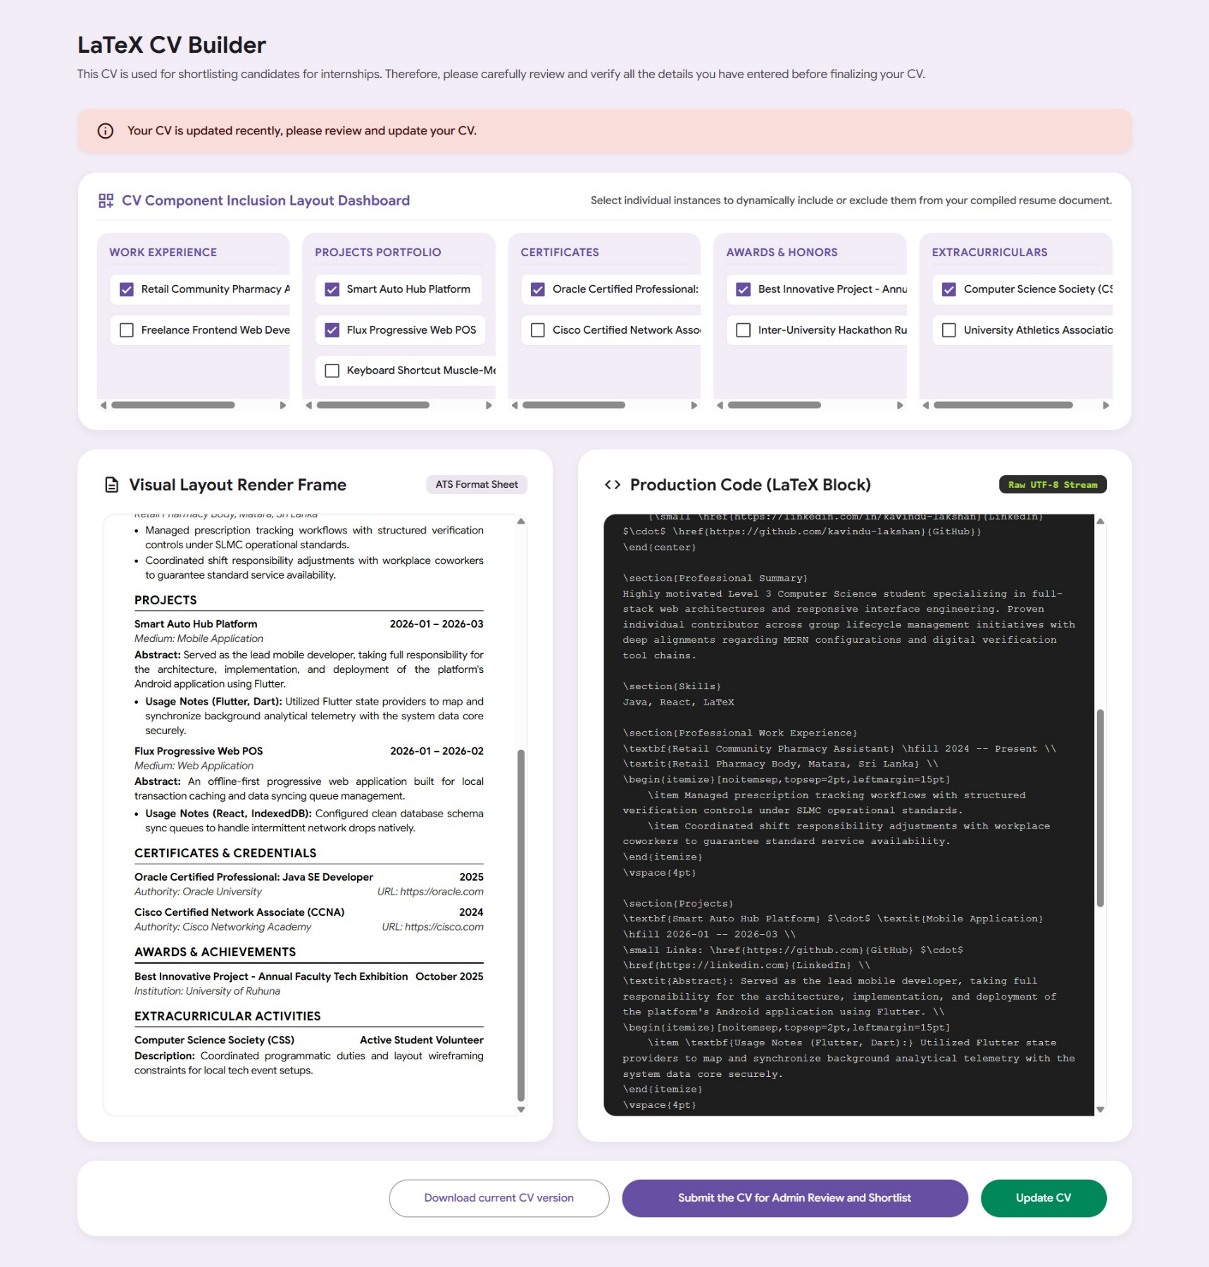

Simple Page Structure Description
- Page Title: LaTeX CV Builder
- Notice Banner: Informational disclaimer reminding students to verify entry fields before final compilation.
- Stateful Warning Banner: A contextual alert box displaying the exact message: "Your CV has been updated recently, please review and update your CV." This banner becomes active only when an unsaved change is made.
- Component Inclusion Layout Dashboard: A grid mapping horizontally scrollable inclusion sub-blocks. Each sub-block contains individual checkbox controls for every single recorded entry:
  - Work Experience Block: Toggles individual employment instances.
  - Projects Portfolio Block: Toggles individual technical project instances.
  - Certificates Block: Toggles individual certification instances.
  - Awards & Honors Block: Toggles individual award instances.
  - Extracurriculars Block: Toggles individual voluntary club instances.
- Symmetrical Workspace Grid: A balanced two-column development layout container:
  - Visual Layout Render Frame (Left Column): A real-time document engine displaying an accurate visual layout of the ATS resume. It displays headers, summary paragraphs, and a clean comma-separated skills list followed by active profile records.
  - Production Code Pane (Right Column): A code presentation box exposing the compiled raw LaTeX string stream. It includes a dedicated inline "Copy Code" button to quickly extract data.
- Footer Controls Action Bar: An aligned bottom menu tracking interface workflow controllers with optimized Material Design widths:
  - Download Button: An outlined element to immediately export the compiled .text file locally.
  - Submit Button: A primary filled layout action button that securely commits the currently compiled version to the administrative review track.
  - Update CV Button: A hidden contextual filled button that surfaces only when changes are made. Clicking synchronizes the visual and LaTeX outputs and resolves the warning state.
Main functionalities available to students on this page:
1. Granular Content Customization (Dashboard Toggles)
- Toggle Individual Work Experiences: Choose exactly which specific jobs to display or hide by checking or unchecking individual checkboxes under the Work Experience sub-block.
- Toggle Specific Portfolio Projects: Control project-by-project inclusion rules for the CV under the Projects Portfolio section.
- Toggle Certificates & Credentials: Dynamically filter professional credentials and certifications on an instance-level basis.
- Toggle Individual Awards & Honors: Explicitly select which recognitions to show in the finalized resume layout.
- Toggle Extracurricular Activities: Separately enable or disable specific club involvements, voluntary roles, or society descriptions.
- Horizontal Dashboard Scrolling: Comfortably scroll through lists horizontally without text wrapping or layout clipping if there are numerous submitted items.
2. Live Document Review
- Review an ATS-Compliant Layout: Use the Visual Layout Render Frame (Left Panel) to view a formatted, high-fidelity render of the resume, complete with a clean comma-separated skills list and strictly ordered sections.
- Inspect Raw LaTeX Code: Use the Production Code Exposer Pane (Right Panel) to inspect the raw, unescaped, UTF-8 compiled LaTeX syntax line-by-line.
3. Stateful System Synchronization
- Live Discrepancy Detection: Automatically trigger a warning banner reading "Your CV is updated recently, please review and update your CV." whenever a checklist item is altered from the current compiled document state.
- Re-Compile & Synchronize State: Click the dynamic "Update CV" button (visible only during state mismatches) to run compilation scripts, regenerate both panels with the latest updates, and clear the warning banner.
4. Code & Document Export Management
- One-Click Code Extraction: Use the "Copy Code" button overlay to immediately copy the entire raw LaTeX code block to the system clipboard.
- Local File Downloading: Click "Download current CV version" to trigger a client-side download operation, saving the current active state locally as a .text file (cv_compiled_report_portfolio.tex).
5. Administrative Workflow Actions
- Submit for Official Evaluation: Click "Submit the CV for Admin Review and Shortlist" to forward the currently compiled version to the administration portal for internship matching.
- Mismatch Guard Validation: Benefit from an automatic warning prompt that alerts the student if they attempt to submit while uncompiled profile modifications exist, preventing accidental submissions of outdated document versions.

Let’s move to the Academic Records Page

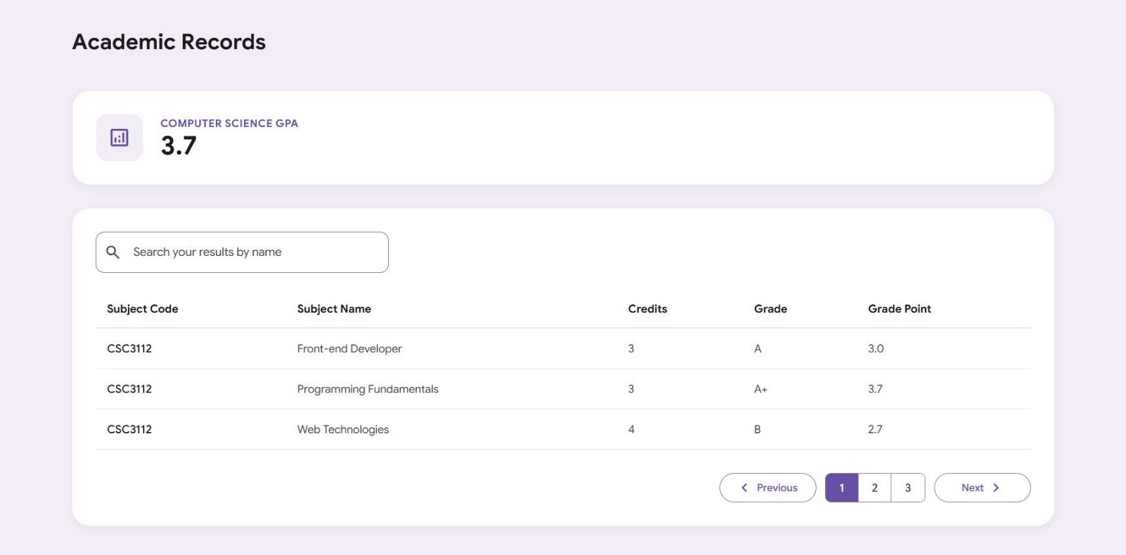
Simple Page Structure Description
- Page Title: The document header establishes the page identity as "Academic Records | Student Portal".
- Main Workspace Container: A structural vertical flex box (.records-container) constrained to a maximum width of 1340px to align neatly with the dashboard design framework.
- Page Header Section: A clean introductory block featuring a bold <h1> header that states "Academic Records".
- GPA Summary Card: A prominent, standalone card container featuring a structured analytics icon, an explicit label reading "Computer Science GPA", and a large typography element highlighting a cumulative score of "3.7".
- Official Academic Results Section: A distinct background card component that centralizes all data discovery and navigation controls. This component includes:
  - Search Field Wrapper: An integrated Material 3 outlined text field block with a leading magnifying glass symbol used to dynamically filter academic transcripts by course name.
  - Tabular Data Grid: A horizontally responsive scroll frame enclosing a structured data matrix with columns tracking Subject Code, Subject Name, Credits, Grade, and Grade Point.
  - Pagination Navigation Bar: A footed layout control cluster housing an outlined "Previous" navigation button with an embedded left-facing chevron icon, a numeric page step-group (displaying pages 1, 2, and 3), and an outlined "Next" navigation button featuring a right-facing chevron icon.

Main functionalities available to students on this page.
- View Prominent GPA Summary: Students can instantly view their official, standalone Computer Science GPA metric featured clearly inside its own dedicated card component at the top of the workspace.
- Search Academic Results: Students can type text queries into the outlined search field to live-filter or look up their transcript rows by subject name.
- Scan Detailed Module Metrics: Students can inspect the comprehensive breakdown of their academic history—including Subject Codes, Subject Names, Credits, Grades, and Grade Points—organized inside a clean tabular matrix.
- Navigate Multi-Page Results: Students can click the interactive "Previous" and "Next" step buttons to flip backward or forward through multiple pages of their records log.
- Jump to Specific Record Pages: Students can select specific page numbers (such as 1, 2, or 3) directly from the navigation counter cluster to jump straight to a desired transcript section.

